2 Budgets

Chapter
2

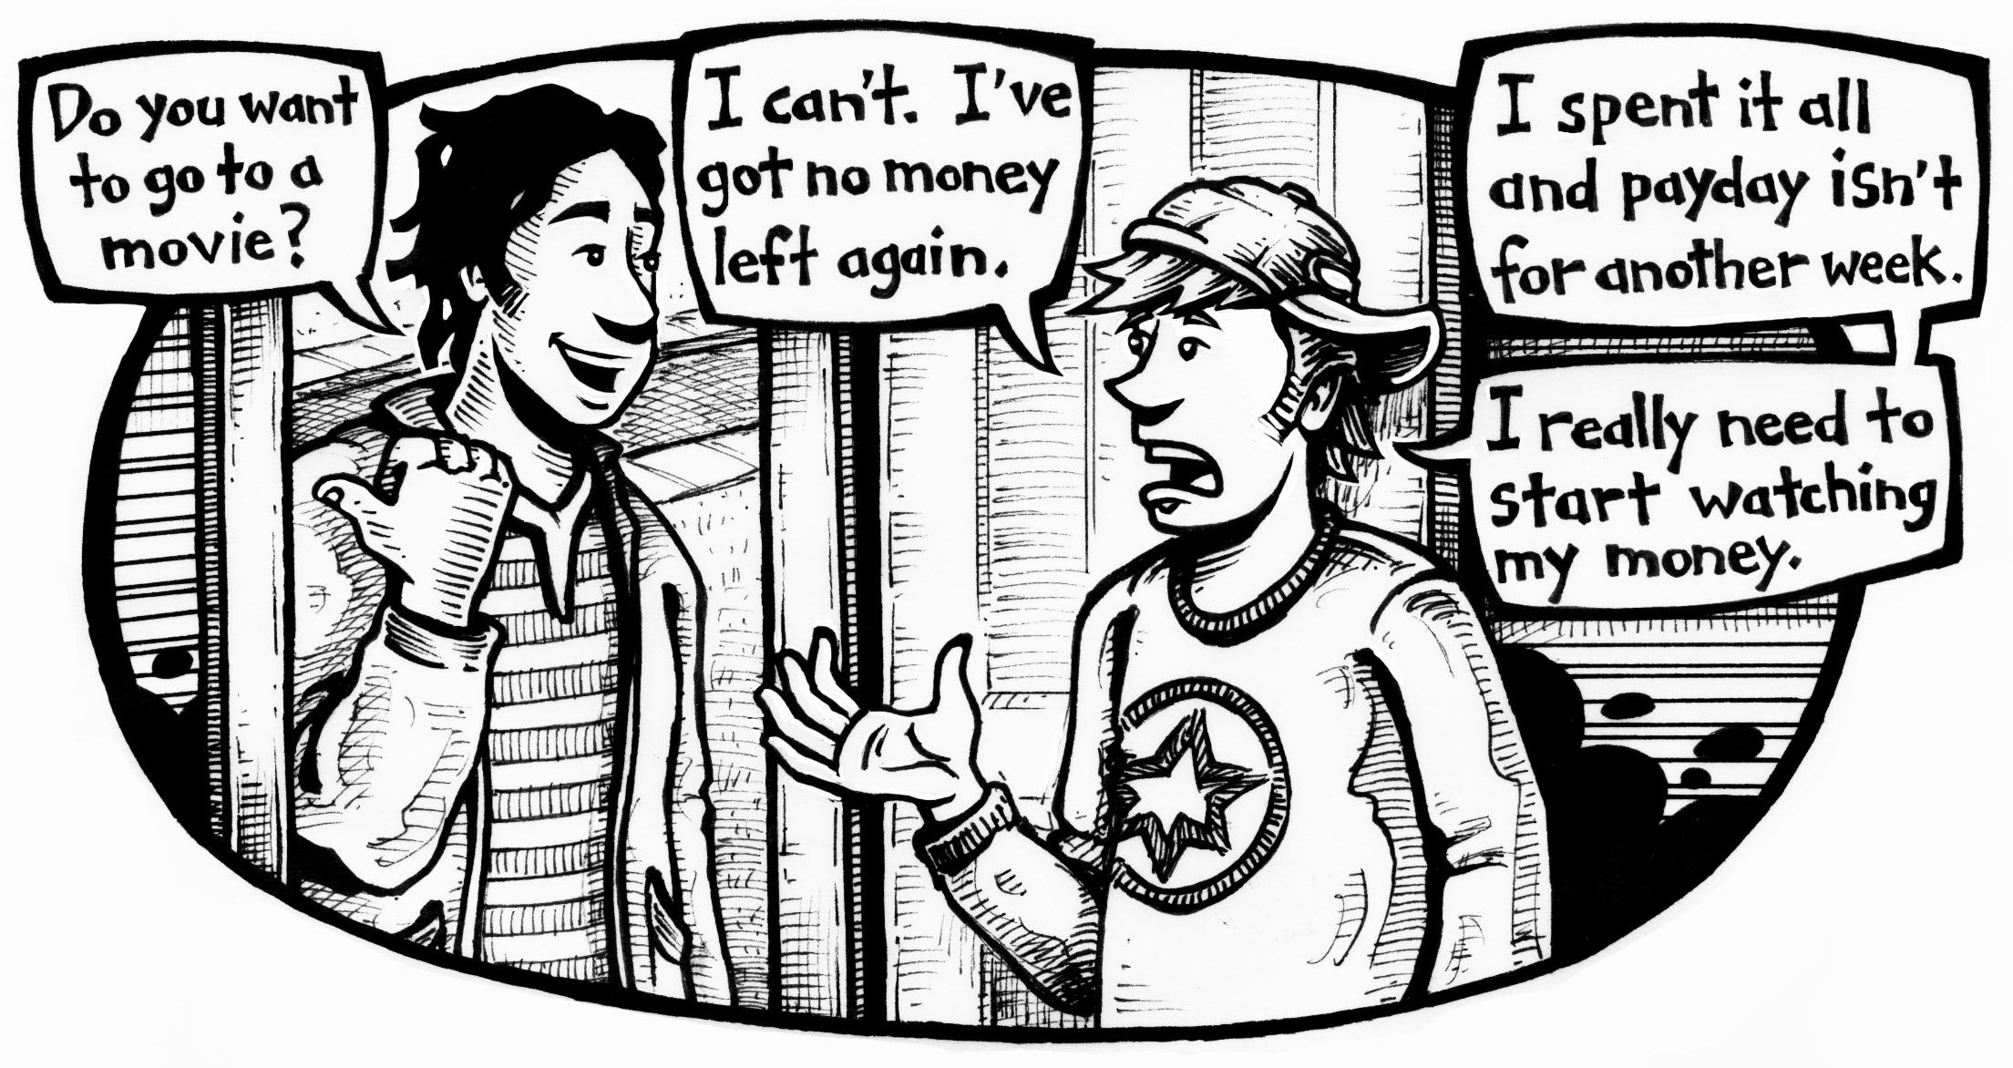
- Why can’t the boy on the right go to the movie?

He has no money left

- How could this situation be avoided?

Through planning

978-0-07-090894-9 Chapter 2 Budgets • MHR 51




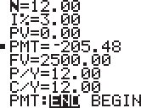

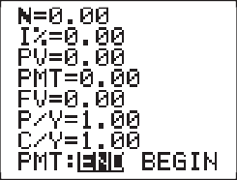

Tech Tip: Using the TVM Solver
Since these calculations involve money, turn on the graphing calculator and press MODE, ↓→→→, ENTER to set all calculations to 2 decimal places.
Press APPS, ENTER, ENTER to access the TVM solver.

Example 1:
Esteban and Suzanne want to take their sons on a vacation to Florida in 1 year. They estimate the trip will cost $2500. They have an account that pays 3% interest per year, compounded monthly. Determine the amount they will need to deposit into the account at the end of each month to reach their goal.
  - N is the number of payments, so N 12 .

Chapter
2
  - I% is the interest rate in percent, so I% 3% .
  - PV is the Present Value (or the amount today), so PV 0 .
  - PMT stands for Payment. PMT is the number we want to calculate, so for now, let PMT 205.48.
  - FV is the future value , so FV 2500 .
  - P/Y is for payments per year, so P/Y  12 .
  - C/Y is the number of times the interest is compounded in 1 year, so
C/Y 12 .
  - The last line deals with when payments are made, so END needs to be highlighted. For all problems in this unit, payment will be made at the end of the pay period.
After you set all of the variables, the calculator does the work. Scroll up to PMT and press ALPHA, ENTER. This directs the calculator to SOLVE
for the payment. PMT = $205 .
Notice that the answer is negative. The TVM solver distinguishes between money received () and money given (). The negative value makes
sense since each payment is money that Esteban and Suzanne give up.




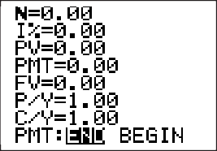
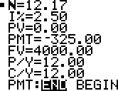
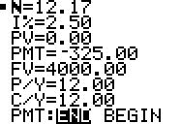

Practice
- Jesse wants to have a party for his girlfriend’s birthday in 6 weeks. He estimates it will cost him $500 for snacks, drinks, and entertainment. His savings account pays 2% interest per year, compounded monthly. How much money does he need
to save weekly? PMT = $ 82 .
- Tatiana wants to buy a surround-sound system for her TV. She wants it in time for her vacation, in 4 months. It costs $1100. Her account pays 1.8% interest per year, compounded monthly. How much does she need to save each month?
PMT = $ 273 .
Example 2:

Chapter
2
Carrie and Bill want to build a deck and landscape their backyard. They estimate it will cost $4000. Their account
pays 2.5% interest per year, compounded monthly. They can afford to save $325 per month.
  - N stands for Number of years (skip for now)
  - I% stands for Interest , so I% = 2.5% .
  - PV stands for Present Value , so PV = 0 .
  - PMT stands for Amount of payment , so PMT = 325 .
  - FV stands for Future Value , so FV = $4000 .
  - P/Y stands for Payment per Year , so P/Y = 12 .
  - C/Y stands for Compounded per year , so C/Y =12 .

Practice
- a) How long will it take Carrie and Bill to save $4000? N = 12 .
  - What payment would they need to make if they already
had $1000 saved? PMT = $247.5 .
  - If the interest rate is lowered to 1.4%, how long will it
take? N = 12 .
  - If the interest rate is 1.4% and they only have 8 months to save, how much would they need to save each month?
PMT = $ 500 .

978-0-07-090894-9 Tech Tip: Using the TVM Solver • MHR 53

Savings Plans
Focus: percent, using technology, planning, goal setting
Warm Up
1. About how many days are in | 2. What is 10% of
6 months? 181 | a) 70? 7
 | b) 120? 12
- How many pay periods are usually in 1 year if you are paid  - weekly? 52  - bi-weekly? 26  - monthly? 12 | 4. What is 10% of
 | a) 238? 23.8
 | b) 119.20? 11.92
 | c) 473.92? 47.392
5. What do the following TVM solver abbreviations stand for?  - PV Present Value  - FV Future Value | 6. Explain the difference between the 2 variables in #5.  PV is the sum of money that must be invested in order toachievea specific future goal.  FV is the is the dollar amount that will accrue over time when that sum is invested.

Chapter
2


Planning for the Future
    - Long-term financial goals help you manage your money.
    - You need to plan ahead to buy a house, go on vacation, get out of debt, or go back to school.
- a) What are your financial goals in the next 5 years?

Start a business

DSWQDEA Purchase a house
    - What major purchases do you see in your future?

House

Vehicle

    - Investigate the cost of 1 of these goals or purchases.

$15,000

    - List the steps you could start taking right now to reach this goal.
Saving
Business plan










    - Compare your goals and plans with a partner.
- Jaspreet is saving for a vacation to Halifax with her friends. She puts $2 a day into a glass jar on her night table.
PM
  - Approximately how much will Jaspreet save in 30 days?

Chapter
2
$60

  - Approximately how much will she save in 6 months?

$362

  - How much will she have in 1 year?

$730

  - State 1 advantage and 1 disadvantage of Jaspreet’s savings method.

It is convenient to everybody since they can easily afford the amount

- Jasira is going to college next year to study culinary arts.
She has 1 year to save $3000. Calculate the amount she needs to save from each paycheque if she is paid
  - weekly $62.5
  - bi-weekly $125
  - monthly $250



- Caleb needs to buy snow tires for his truck. They will cost $1000.
  - If he saves $120 each week, will he have enough to buy the tires in 6 weeks?

No, 120 x 6 = $720

  - How much will Caleb have to save each week in order to buy the snow tires in 6 weeks?
1000/6 = $167

- In 9 months, Rob wants to purchase a $1200 snowboard. He has an account that pays 2.5% interest per year, compounded monthly. Use a TVM solver to determine how much he should put in the account each month.

Chapter
2
N: 9 , I%: 2.5 , PV: 0 , PMT: 100 , FV: 1200 , P/Y: 12 , C/Y: 12 , PMT: END BEGIN
- a) Find an article about financial planning on the Internet or in a print resource. Read the article.
      - Describe the attitude of the author toward financial planning.
The author is optimistic that investment in financial planning is very rewarding.

      - How does the author use statistics to promote the ideas in the article?

He uses percentage by saying 80% of the people who are in financial planning are really benefiting.

    - Gross pay is an employee’s total earnings before deductions, such as income tax, are taken off. An employee who makes $9.50/h and works 10 hours has a gross pay of
Go to pages 45–50 to write the definitions for
gross pay and net pay in your own words.
$95.
    - Net pay is gross pay after all deductions are taken off.

- Last spring, Rhys started working after school.
The table shows the amounts of his first 4 paycheques.

Pay Date | Net Pay | Amount Saved
March 17 | $212.98 | $21.30
March 31 | $244.30 | $24.43
April 14 | $192.09 | $19.209
April 28 | $263.87 | $26.387

  - Rhys saved 10% of his net pay. Calculate the amount he saved from each paycheque. Write your answers in the chart. The first one is done for you.

  - Estimate the average amount Rhys can save each month.

Chapter
2
$23.342

  - Rhys is saving for a $1500 motorcycle. Use a TVM solver to determine how many months it will take him to reach his goal. He has an account that earns 2% interest, compounded monthly.

N: , I%: 2% , PV: 0 , PMT: , FV: 1500 , P/Y: 12 , C/Y: 12 , PMT: END BEGIN

Check Your Understanding
1. Jackson works part-time and earns about $450 every 2 weeks. He wants to buy a $6000 motorcycle. Design
a savings plan for Jackson. He wants to buy his motorcycle within 1 year.

N: 12 , I%: 1% , PV: , PMT: 500 , FV: $6000 , P/Y: 12 , C/Y: 12 , PMT: END BEGIN

Slicing Up the Pie
Focus: number sense, proportional reasoning, interpreting and displaying data
Fraction | Percent | Decimal
_9  10 | 90% | 0.9
7/20 | 35% | 0.35
2/25 | 8% | 0.08

Warm Up
1. Solve without a calculator.  - 40 is what percent of 80? 50%  - 20 is what percent of 80? 25%  - 10 is what percent of 80? 12.5%  - 50 is what percent of 80? 62.5% | 2. Complete the chart.
3. Solve without a calculator. | 4. What is 10% of
a) 22% of $100 $22 | a) $212.60? $21.26
b) 22% of $200 $44 | b) $348.71? $34.871
c) 22% of $300 $66
5. An employee being paid  bi-weekly receives Salary twice or Salary thrice pays per month. | 6. Explain why there are  2 possible answers for #5.  Possibility of a leap year

Chapter
2


Managing Your Money
    - Many people spend more time planning a party than managing their money.
    - Whether you rent a basement apartment or own a large house, you can predict and manage most of your income and many of your expenses.
- Brainstorm some household and living expenses you or your family might pay in a typical month.

Groceries, Utensils, pets, tv, internet

- Essential expenses are not optional. These include such things as groceries.
Go to pages 45–50 to write the definitions for essential expense and non- essential expense in your own words. Give an example of each.
- Non-essential expenses are optional. Going to the movies or out to dinner is a non-essential expense.

- Classify your list of expenses from #1 as either essential or non-essential.
Essential Expenses
Non-Essential Expenses

Essential Expenses |  | Non-Essential Expenses
Groceries |  | Going out on weekends
Utensils |  | Going to movies
Food |  | Dry Cleaning
Pet food
Cable tv
Internet
Security

- Fixed expenses are paid at the same time each week or each month. They are generally the same amount from payment to payment.

Chapter
2
Go to pages 45–50 to write the definitions for fixed expenses and variable expenses in your own words. Give an example of each.
- Variable expenses are expenses that can change in their frequency or their amount.

- Classify your list of expenses from #1 as either fixed or variable.

Fixed Expenses |  | Variable Expenses
Groceries |  | Security
Internet |  | Going out for Dinner
Tv |  | Going out for a movie
Rent |  | Dry cleaning
Utilities e.g. electricity & water.

- Dylan graduated from high school last year and works full-time at a job that pays $11.25/h. He lives with his parents. He drives his own car, which will be paid in full in about 1 year.
  - Assuming he works 40 hours per week, calculate Dylan’s bi-weekly gross income.
$900

  - Dylan’s net earnings are about 85% of his gross earnings. What is his approximate bi-weekly net pay? $765

  - Dylan saves 10% of his net pay in a long-term savings account. How much does he put into the account
Each pay?
$76.5

  - Estimate the amount that he will deposit into this account in 1 year. $1989

Chapter
2


  - Most months, Dylan’s total take-home pay is $ 1790.10 .
  - Some months, his total take-home pay is $ .
  - Dylan pays his parents $300 per month to help with household expenses. In a 2-pay month, $300 is
approximately 19.608 % of Dylan’s net earnings.
  - In a 3-pay month, $300 is approximately 19.608 % of his net earnings.
  - List Dylan’s possible car-related expenses. Circle the fixed expenses.

Insurance

Car wash

Garage

s

- A budget is an organized income and spending plan.
Go to pages 45–50 to write the definition for budget in your own words.
- a) Hafeeza lives with her young son. Her monthly expenses are listed in the chart below. Determine the percent of her total income for each expense. Round all calculations to the nearest percent.

Chapter
2

Item | Amount ($) | Calculation | Percent of Income
Rent | 635 |  | 31.59
Food | 250 |  | 12.44
Daycare | 300 |  | 14.93
Savings | 100 |  | 4.975
Phone | 50 |  | 2.488
Car loan | 115 |  | 5.721
Car insurance | 105 |  | 5.224
Gas & other car expenses | 180 |  | 8.955
Gifts, charities | 50 |  | 2.488
Vacation fund | 50 |  | 2.488
Clothing | 100 |  | 4.975
Entertainment | 75 |  | 3.731
Total | 2010
- Circle the non-essential items in Hafeeza’s budget. Draw a rectangle around the fixed items.
- What is the total amount budgeted for
essential items? $ 985 variable items? $ 1025
- Hafeeza is planning a trip with her son to Montreal
to visit family. She estimates the vacation will cost $1000.
If she starts the vacation fund today, when will she have enough saved? 20 Months
- Kaylee works part-time after school and on weekends. She earns $120 per week. She is learning how to manage her money by tracking her expenses.
  - Determine Kaylee’s total expenses for each week in October. Then, calculate the total of each item for all 4 weeks.

Chapter
2
Week of → | October 1–7 | October 8–14 | October 15–21 | October 22–28
Item ↓ | Amount ($) |  |  |  | Total
Lunches | 25.00 | 20.00 | 19.00 | 23.00
Clothes |  | 32.75 |  | 45.60
Mom | 20.00 | 20.00 | 20.00 | 20.00
Going out | 18.00 | 12.00 | 35.00 | 32.00
Phone |  |  | 44.30
Miscellaneous | 17.54 | 16.00 | 20.00 | 13.50
Saving | 39.46 | 19.25 | –18.30 | –3.50
Total

  - Explain the negative amounts in Kaylee’s savings.

Inappropriate management of fund

  - Explain “Miscellaneous.”

Failure to have well laid plan on the saving

  - Make 3 suggestions that Kaylee can use in November to improve her situation.
- Have a well laid plan

- Have a fixed amount to save

- Give saving a priority


  - Determine the average amount spent each week for each category. Then, determine the percent of Kaylee’s total income spent in each category. Round calculations to the nearest percent.
To find the weekly average, divide the
4-week total by 4.

Item | 4-Week Total | Weekly Average | Percent of Total Income
Lunches | 87 | 21.75 | 18%
Clothes | 78.35 | 19.56 | 16%
Mom | 80 | 20 | 17%
Going out | 97 | 24.25 | 20%
Phone | 44.30 | 11.075 | 9%
Miscellaneous | 67.04 | 16.76 | 14%
Savings | 36.91 | 9.22 | 0.08%

  - Some people prefer to see data in a graph. Create a circle graph showing the Percent of Total Income column. Estimate the size of each pie slice.
Chapter
2
  - Use the Tech Tip on pages 52–53 to create a spreadsheet that displays Kaylee’s expenses on a circle graph. Compare the accuracy
of your sketch to the graph created by the computer.

Check Your Understanding
- You have organized Kaylee’s budget information in several ways.
  - How can a circle graph help you interpret how you spend your money? It draws a comparison with other elements

  - How can a spreadsheet help you interpret how you spend your money? It has advanced formulaes.

Tech Tip: Using a Spreadsheet
The following instructions are for use with Microsoft Excel. Other spreadsheet programs will use similar commands.
- Open the program so that a blank sheet appears.
- In this Tech Tip, you will use the data in #6 on pages 62–63.
  - Type “Week of” in cell A1. Press Tab to move 1 cell to the right (to B1). Type “Oct 1–7,” press Tab, and continue entering the rest of the data in that row.

Save your work.
  - Press Enter and you should move directly to cell A2. Otherwise, move the cursor to A2. You can leave out the “Item, Amount, Total” row. Enter the rest
of the data. Enter 0 where you see blanks to indicate no spending.



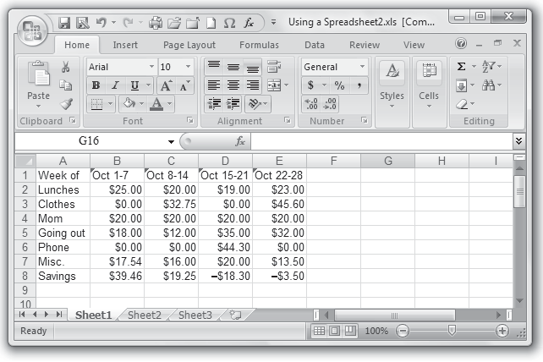

- Your spreadsheet should now look like this.

Chapter
2

  - Bring the cursor above the letter B. The plus-sign cursor should change to a downward pointing arrow. Click and drag to highlight columns B through F.

  - Right click, select Format Cells, and click on Currency.
Make sure that Decimal places is 2 and the Symbol
is $. Click OK. Your spreadsheet will now display the data as money values.
Some spreadsheet programs will show a small triangle in the top corner of the cell. This shows you that the cell has been programmed for a specific function.

Save

- a) Click on cell B9. Click on the ∑ symbol in the top toolbar. The cells B1 to B8 should be highlighted. Press Enter. $120.00 should appear in B9.
Alternatively, click and drag to highlight the cells you wish to add, and then click ∑.
    - Program the spreadsheet to total the data on the rows and columns so that there are appropriate values in cells C9 to E9 and cells F2 to F8.
Some spreadsheet programs will show a small triangle in the top corner of the cell. This shows you that the cell has been programmed for a specific function.

    - Program F9 to total the cells above it or to its left.
$480.00 should appear.
- To create a circle graph, click and drag to highlight cells A2 to A8. Hold the Ctrl key while you highlight cells F2 to F8.
- a) Click Insert and select Pie or Chart. Select the first option under 2-D Pie.
b) Click anywhere on the graph to highlight. Click Layout,
Data Labels, More Data Label Options. Select the options of your choice. Try different displays or combinations. Print your finished graph.
- Click on Sheet 2 and create a circle graph with the following data.
  - In A1 type “Month.” In A2 to A13 type the months of the year in order.

Save


  - In B1 type “Gasoline.” In B2 to B13 enter $75, $66, $112,

Chapter
2
$90, $123, $109, $265, $134, $122, $180, $105, $127.
  - Try other displays, for example, a bar graph or a line graph. Look at the displays of other students. Which
display do you like best for this type of data? Pie Chart 3D

978-0-07-090894-9 Tech Tip: Using a Spreadsheet • MHR 65

Track Your Spending
Focus: planning, goal setting, number sense, interpreting and displaying data

Chapter
2
Warm Up
- You have been keeping track of your spending for several weeks. How much did you spend on entertainment?  $400 | - What forms of entertainment did you spend money on?  Video games  TV Movies
3. What is an advantage to | 4. Add.
tracking your expenses?  It helps me control my budget. | a) $134 1 $26 5 $160
It reduces impulse spending. | b) $21 1 $72 5 $ 93
It helps me track my financial progress. | c) $56 1 $29 5 $ 85

Analysing Your Data
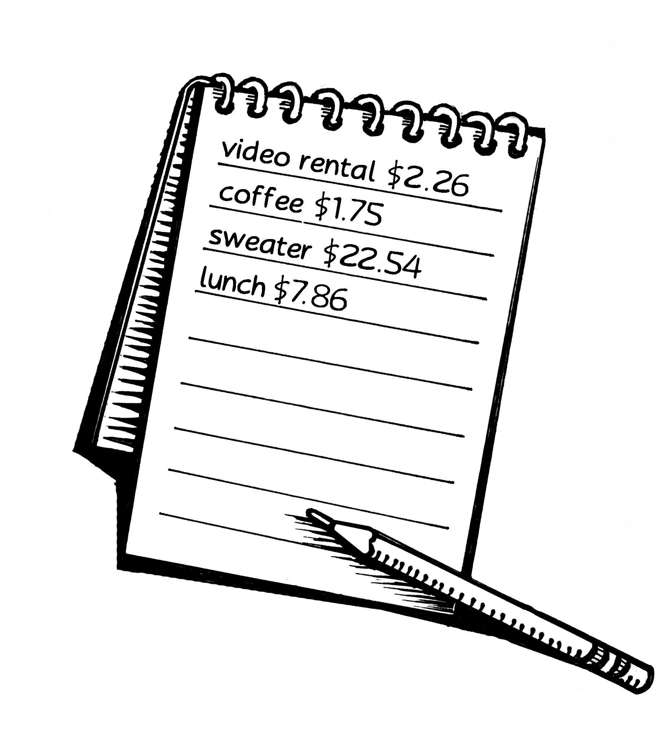
    - Now that you have been tracking your spending, you should have a good understanding of how you spend your money.
- Look at your budget tracker.
  - List the essential items you have purchased.

Phone, Clothes, Bike, Laptop, furniture
  - List the non-essential items you have purchased.

Play Station, Games, Movies & drip
- Discuss your list with several peers.
  - What items do you consider essential that one of the others considers non-essential?
Bikes & Clothes

  - What items do you consider non-essential that one of the others considers essential?
Play station & Movies.

- a) What regular payments do you make?

Rent, Shopping, transport, lunch, Gaming

- Which of these are fixed?

Rent, Shopping, lunch

- Which of these are variable?

Gaming & transport


- Many people group their expenses by category.
MALL SPECIAL
- Housing, transportation, and food make up the largest amount of many budgets.
- Some people think that clothing, entertainment, and gifts are even more important.
CITY BUSLINES
- Create a number of categories to group similar items that you spent money on. Refer back to Section 2.2 for some additional examples.

Chapter
2

- Determine the total spent for each category. Use the table below as an organizer.

Week of | Oct 1-7 | Oct 8-14 | Oct 15-21 | Oct 22-28 | Oct 29-Sept 6 | Sept 7-14
Category | Amount ($) |  |  |  |  | Total
Lunches | 20.00 | 18.00 | 19.00 | 21.00 | 19.00
Games | 30.00 | 31.00 | 29.00 | 30.00 | 29.00
Clothes | 35.00 | 34.00 | 33.00 | 32.00 | 36.00
Going Out | 13.00 | 14.00 | 12.00 | 13.00 | 14.00
Phone | 23.00 | 22.00 | 23.00 | 22.00 | 21.00
Music | 30.00 | 29.00 | 28.00 | 31.00 | 31.00
Movies | 15.00 | 16.00 | 17.00 | 16.00 | 17.00
Savings | 25.00 | 24.00 | 23.00 | 23.00 | 25.00
Siz & Mom | 20.00 | 21.00 | 22.00 | 21.00 | 23.00
Misc | 12.00 | 11.00 | 12.00 | 13.00 | 11.00
Total

- a) Enter the data from the table in a spreadsheet.
  - Program the spreadsheet to calculate all totals.
  - Create a circle graph showing the percent value of each category.
  - Print and attach a copy of the circle graph.

  - Looking at this graph, are there areas where you might reduce your spending? List them.

Chapter
2

Yes, Games & Music.
Y

  - Are there areas where you would like to increase your spending?

Yes, Savings & Going out

- a) Have you identified any spending patterns that you would like to change?

Of course, yes
,

b) State 3 things that you will do during the next month to improve your financial situation.

Save more, Reduce on Games and start planning to avoid miscellaneous

- Many people make changes to their budget when they are saving for something important.
- Keeping a visual reminder of how much they have saved helps some people keep saving.

- a) You want to make a large purchase. Perhaps you want to buy a stereo system. Maybe you want to take a vacation in the Caribbean or visit family in another

$600
$500
$400
$300
$200
$100

country. Research the cost of that purchase.
Goal: Fly to the Dominican Republic

Buy a stereo System , $500

- How could you change your spending habits to allow you to save for that goal?
Start saving on the goal and minimize on my expenses especially games & movies

- How much could you save each month by taking the actions in part b)? $25

Chapter
2
- Predict how long it will take you to reach your goal. 20 weeks.
- a) With your goal in mind, set up a spreadsheet
or paper template to track next month’s expenses.
- What is your goal?

To buy a stereo system in 20 weeks

- What steps do you plan to take in the next month to help reach it?

Save more

Check Your Understanding
- Re-assess your budget in a month. Did you accomplish what you planned in #7b)? yes
- What changes could you make to help you achieve
your goal in the next month? Continue Saving

Living Expenses
Focus: number sense, income versus expenses

Chapter
2
Warm Up
- An employee is paid weekly and was last paid April 6. When are the next 2 paydays?  April 13 & 20 | - An employee is paid bi-weekly and was last paid April 6. When are the next 2 paydays?  April 20 & May 4
3. Round to the nearest $10.  a) $128.75 $130.75  b) $62.45 $60.45  c) $206.90 $200.90 | 4. Add the rounded values from #3.  130.75 + 60.45 + 200.90=  392.10
5. State 2 common fixed living expenses.  Rent Payment  Real Estate taxes | 6. State 2 common variable living expenses.  Utility bills like electricity  Packaging Costs

Using Your Budget Template
    - The car. The kids. Groceries. Saving for a house. Taking care of your living expenses doesn’t have to be overwhelming.
    - You need to keep track of what money comes in and manage what money goes out.
    - Save some of what you make. Invest some. Give some away.
- One way of organizing your expenses is to use a budget template. This is a list of common sources of income and expenses. You can get them from banks, financial planners, or the Internet.
Go to pages 45–50 to write the definition for budget template in your own words.
  - Go to www.mcgrawhill.ca/books/workplace12 and follow the links to budgeting. Look at 2 different budget templates. Choose a template that looks easy to use.
  - Look at the templates collected by classmates. Discuss why each of you chose the template that you did.

- Below is a list of expenses from a typical budget template.

Chapter
2

Home  Mortgage/rent | Daily Living | Transportation | Entertainment
 | Groceries | Car payments  Cable or satellite TV
Utilities | Child care | Fuel | Video/DVD rentals
Home/cell phone | Dry cleaning | Insurance | Movies/plays
Internet | Dining out | Repairs | Concerts/clubs
Home repairs | Housecleaning | Car wash | Books
Home decorating | Clothing | Parking | Music: MP3s, CDs, etc.
Home security | Gifts | Public transit
Garden supplies | Salon/barber/stylist
Property tax | Credit card/loan payments
Health and Recreation | Vacations | Saving/ Investing | Dues/ Subscriptions
Club/team/gym memberships | Travel: bus, car, plane, train | Savings accounts | Magazines
Insurance | Accommodations | RRSP | Newspapers
Prescriptions | Food | RESP | Religious organizations
Over-the-counter drugs | Souvenirs | Stocks | Charity
Veterinarians/pet medicines | Child/pet care  Other investments
Life insurance
Sports equipment
Toys/child gear
  - Circle the items that apply to you now.
  - Draw a rectangle around the items that might apply to you next year.
  - Highlight 5 essential and 5 non-essential expenses.
  - Use different colours to highlight 5 fixed expenses and 5 variable expenses.

- Stephanie works part-time after school and some weekends. Her monthly budget for February is shown.

Income ($) | Expenses ($)
Feb 2–16 312.61 | Save for college | 200 | Clothes | 95
Feb 17–Mar 3 290.09 | Room and board | 160 | Cell phone | 20
 | Spending money | 100
Total Income 5 | Total Expenses 5
Balance (Income 2 Expenses) 5
  - What is Stephanie’s total income? $ 602.7
  - What are her total expenses? $ 575
  - Determine Stephanie’s balance. $ 27.7

Chapter
2
  - Explain the meaning of her monthly balance.

S the money is not well budgeted for.

- Mario moved out of his parents’ house into a 2-bedroom apartment 4 months ago. He has recorded some of his expenses on a piece of paper.

Jan 1 – first and last months’ rent – $1180
Jan 7 – activate cable – $65
Jan 19 – top up cell phone – $40
Feb 1 – rent – $590
Feb 18 – gas bill – $117.40
Feb 22 – hydro bill – $86.23
Mar 1 – rent – $590
Mar 11 – cable bill – $103.06
Mar 18 – gas bill – $123.64
Mar 29 – top up cell phone – $50
Apr 1 – rent – $590
Apr 18 – gas bill – $93.68
Apr 22 – hydro bill – $92.91

- Total Mario’s expenses by month and by item.

Month ($) |  | Item ($)
Jan | 1180 1 65 1 40 5 =1285 | Rent | 1180 1 590 1 590 1 590 5 = 2950
Feb | 590, 117.40, 80.25 = 787.65 | Cable | 65, 105 = 170
Mar | 590, 105.00, 125.04, 50 = 870.04 | Cell phone | 40, 50 = 90
Apr | 590, 95.08, 92.91 = 777.99 | Gas | 117.40, 125.04, 95.08 = 337.52
 |  | Hydro | 92.91

- Which expenses do you think will decrease over the next few months? Explain your answer.

Which expenses will change between winter and spring?

Gas because it has been on the decline for the past few months

- Look at your budget template or the one on page 71. List expenses that Mario has left out of his budget.
Chapter

2

Internet, food, Insurance

- If 1 month’s rent should not exceed 1 week’s net income, approximate the minimum weekly
net income that Mario needs in order to be able to afford to live in this apartment.

590

Check Your Understanding
1. a) Create a list of living expenses that a couple with
a baby would have that a couple living alone would not.

- Suggest ways the couple might adjust their budget to pay for these extra expenses.
Save a lot, Budget,
Minimize on other expenses

  - Managing Change
Focus: number sense, balancing a budget

Warm Up
1. George earns $14.50/h and works 36 hours per week. What is his bi-weekly gross income? = $1,044 | 2. If George’s net income is 80% of his gross income, what is his bi-weekly net income?  =$835.20
3. If George’s monthly expenses are $1450, what is his balance in a 2-pay month? =$440.8 | 4. How much money do you think George should save each month? Why?  $220.4 it is the deficit after expenses.

Developing a Balanced Budget

Chapter
2
    - A budget is balanced when the money coming in equals the money going out. The money going out can include savings and investments.
Go to pages 45–50 to write the definition for balanced budget in your own words.

- a) Luca is in grade 12 and works part-time after school. His weekly earnings average $125. Write each week’s earnings in the Income column below.

Income ($) | Expenses (approximate $)
$125 | Saving | $200
$125 | Car Insurance | $125
$125 | Gas | $70
$125 | Entertainment | $100
Total Income $500 | Total Expenses $495
Monthly Balance (Income 2 Expenses) $5

  - Each month, Luca saves $200. His car is paid for. His car insurance costs about $125. He spends about
$75 on gas and about $100 on entertainment. Write the data in the Expenses column.

  - Complete the last 2 rows of the table for Luca’s balance.
  - Luca’s budget is BALANCED because his
expenses equals his income .

- Bill is a single, 28-year-old man.
- He has a full-time job with regular bi-weekly take home pay of about $750.
- He has income from a second job of about
$200 per month.
- He rents a 1-bedroom apartment for $634 per month.
- He does not own a car and uses public transportation. A transit pass costs $75 per month.
- Bill has a personal loan, which costs him $238 monthly.
- He spends about $100 per week in groceries.
- a) In the table below, list other expenses that Bill might have. Estimate the monthly cost of each expense.
- Calculate Bill’s total income for a month in which he receives 2 pays from his full-time job $1500 .
- Balance Bill’s monthly budget. Keep a running total
of his remaining income by deducting each expense from the total calculated in part b). How much does Bill have left for savings at the end of the month?

Look at Section 2.4 or your budget tracker from Section 2.3.

Chapter

2

Item | Cost ($) | Opening Balance: Remaining Income ($)
Rent | 634
Transit pass | 75
Loan | 238
Groceries | 100
Food | 200
Entertainment | 200
Insurance | 100
Going out | 150
Sister | 150
Misc | 100

  - Bill is losing his part-time job at the end of the week.
- a) If next month is also a 2-pay month at his full-time job, calculate Bill’s total income for next month
$1500 .
- Which item(s) from the table in #2c) must stay the same?
Transit pass & rent

- Which item(s) from the table in #2c) can change?
Entertainment, Going Out & misc

- Design a balanced budget for Bill’s reduced income.

Chapter
2
Item | Cost ($) | Opening Balance: 383 Remaining Income ($)
Rent | 634 | 634
Transit pass | 75 | 75
Loan | 160 | 78
Groceries | 60 | 40
Entertainment | 100 | 100
Going Out | 100 | 50
Insurance | 60 | 40
Food | 100 | 100

- If Bill’s financial situation remains the same for a few months, what other decisions might he have to make to keep his budget balanced?

Move to a house with lower rent.

  - It’s now 6 months later and Bill has a new job.
  - His hourly rate is $16.50.
  - He works 40 hours per week and takes home approximately 80% of his gross income.

- a) Calculate Bill’s new weekly net income $528 .
- Calculate his monthly net income for a 4-pay month and for a 5-pay month $4,752 .
- If there is money left over after paying for all
of his monthly expenses, what could Bill do? Prioritize your choices. Open saving account

- Design a balanced budget for Bill with the information you know for a 4-pay month. Include the same items as you did in �2c�. �eel free to add new items.

Chapter
2

Item | Cost ($) | Opening Balance: Remaining Income ($)
Rent | 634
Transit pass | 75
Loan | 200
Groceries | 100
Food | 200
Clothes | 150
Going Out | 120
Siz & mom | 150
Phone | 44
Misc | 20

Check Your Understanding
1. Brainstorm some life changes that could affect a budget. Describe how you would adjust the budget for each life change.

Saving for retirement

Paying a debt

Chapter 2 Review
- Martin wants to go to college in 1 year to study landscaping design. He needs to save $2500. Calculate the amount Martin needs to save from each paycheque if he is paid
  - Weekly = $53 b) bi-weekly $104.17

- a) Tanika and Avi are saving $400 per month for a down payment on a house. They have an account that pays 3% interest per year, compounded monthly. In approximately how many months will they have $8000 saved?
N: ____, I%: _____, PV: ________ , PMT ,

FV: ______ , P/Y: ____, C/Y: ____, PMT: END BEGIN

Chapter
2
N: 20 , I%: 3% , PV: 0 , PMT: $400 ,

FV: $8000 , P/Y: 12 , C/Y: 12 , PMT: END BEGIN
b) If Avi and Tanika wanted to have the $8000 down payment saved in exactly 1 year, how much would they need to save each month?
N: 12 , I%: 3% , PV: 0 , PMT: 663. ,

FV: 8000 , P/Y: 12, C/Y: 12, PMT: END BEGIN

- a) State 2 common fixed expenses.
N: ____, I%: _____, PV: ________ , PMT ,

FV: ______ , P/Y: ____, C/Y: ____, PMT: END BEGIN

Rent income Mortgage arrears

- State 2 common variable expenses.
Transport cost , Utility costs like electricity

- State 2 common non-essential expenses.
Car expenses
Debt repayment

- State 2 common essential expenses.
Food
clothing

- Marina works part-time after school and some weekends. Her monthly budget for April is shown.

Income ($) | Expenses ($)
Apr 2–16 164.55 | Save for own car | 100 | Clothes | 50
Apr 17–May 1 182.09 | Spending money | 75 | Cell phone | 20
 | Car insurance | 40 | Gas | 40
Total Income 346.64 | Total Expenses 325
Balance (Income 2 Expenses) 5
  - What is Marina’s total income for April? $ 346.64
  - What are her total expenses? $ 325
  - Calculate her monthly balance. $ 21.64

Chapter
2
  - Explain what is meant by having a balanced budget.

Expenses do not exceed your income

  - Marina’s hours at work have been cut. She expects to lose about half of her monthly income. Estimate her income for May.
$ 173.32

  - Change Marina’s budget to create a balanced budget for May.

Item | Cost | Remaining Income
Spending Money | 30 | 45
Car Insurance | 20 | 20
clothes | 25 | 25
Gas | 20 | 20
Cell phone | 10 | 10
total | 105 | 120

978-0-07-090894-9 Chapter 2 Review • MHR 79

Chapter 2 Practice Test
- Karina plans to attend a community college in 1 year to study culinary arts. She thinks that she will need to save $4000. Calculate the amount Karina needs to save from each paycheque if she is paid
  - bi-weekly = $167 b) weekly = $83

- Circle the fixed expenses. Draw a box around the non-essential expenses.
Car payments
Groceries

Chapter
2
Gym membership
Lottery tickets
Electricity
Digital cable TV
 | Bus pass | Pet food
 | Rent | Car insurance
 |  | Clothing
Golf clubs

- Trevor holds 2 jobs. He works part-time after school and on weekends. His monthly budget for October is shown.

Income ($) | Expenses ($)
Oct 4–18 272.59 | Car insurance | 110 | Clothes | 70
Oct 19–Nov 2 287.09 | Money to Mom | 100 | Cell phone | 70
 | Gas | 80 | Saving | 50
 | Spending money | 80
Total Income 559.68 | Total Expenses 560
Balance 0.1

  - What is Trevor’s total income for October? $ 559.68
  - What are his total expenses? $ 560
  - Calculate his monthly balance. $0.1
  - Explain the meaning of a balanced budget.

Expenses are equal to income and does not exceed income

  - Trevor’s hours at work have been cut. He expects to lose about
$75 per pay. Estimate his income for next month. $ =484.68

  - Change the amount spent on each item in Trevor’s budget as necessary to create a balanced budget for November.

Item | Cost | Remaining Income
Car Insurance | 60 | 50
Money to mom | 70 | 30
Gas | 50 | 30
Spending money | 60 | 20
Clothes | 50 | 20
Cell Phone | 50 | 20
savings | 30 | 20
- a) A couple is saving $200 per month in an account so they can replace the roof of their house as soon as possible. The

Chapter
2
account pays 2% interest per year, compounded monthly. In approximately how many months will they have $6000 saved?
N: 30 , I%: 2% , PV: 0 , PMT: $200 ,

FV: $6000 , P/Y: 12 , C/Y: 12 , PMT: END BEGIN
N: ____, I%: _____, PV: ________ , PMT ,

FV: ______ , P/Y: ____, C/Y: ____, PMT: END BEGIN
- If the couple wants to have the $6000 saved in 2 years, how much would they need to save each month?
N: 24 , I%: 2% , PV: 0 , PMT: 246 ,

FV: $6000 , P/Y: 12 , C/Y: 12 , PMT: END BEGIN

- Is fixing the house roof an essential or a non-essential expense? Why do you think so?
N: ____, I%: _____, PV: ________ , PMT ,

FV: ______ , P/Y: ____, C/Y: ____, PMT: END BEGIN

Essential it is part of basic needs.s

978-0-07-090894-9 Chapter 2 Practice Test • MHR 81

Task: Out of Control
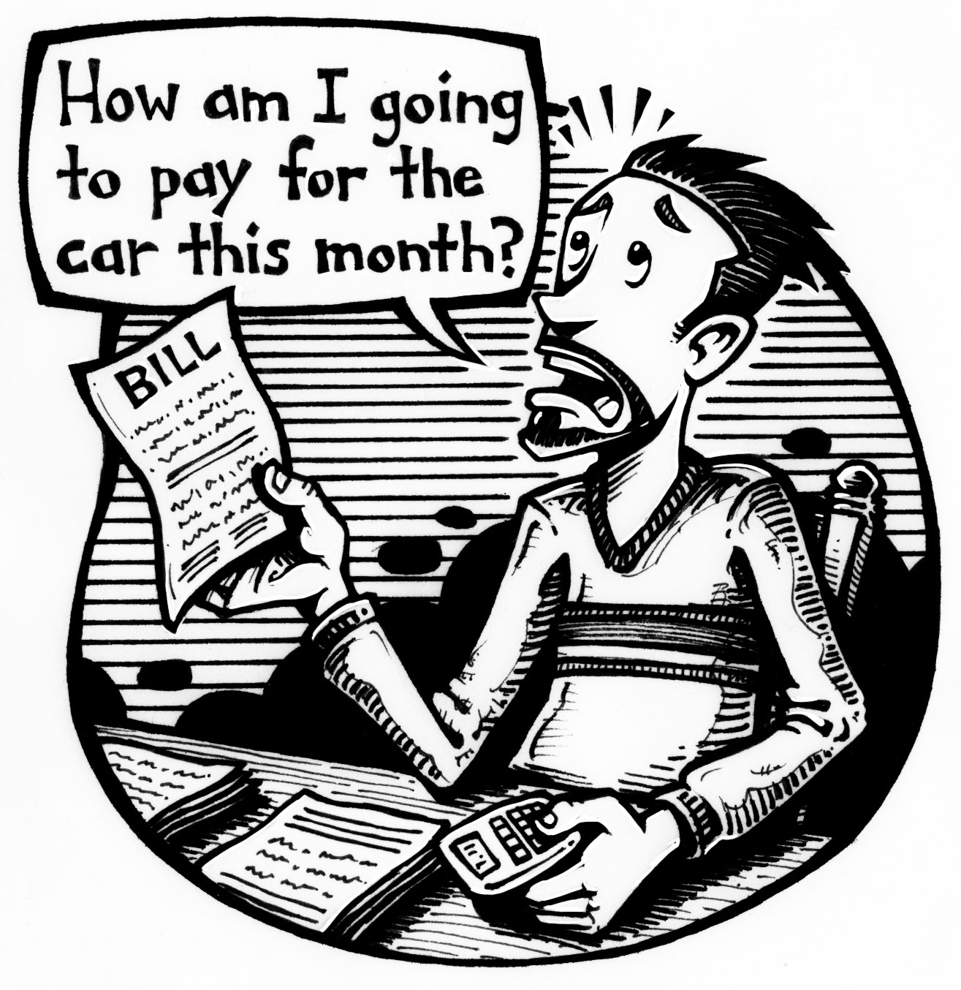

Chapter
2
- Terry is a 43-year-old divorced man with 2 children.
- His take-home pay is $4123 per month.
- He pays $1250 per month in child support.
- He pays $1600 per month for his mortgage.
- His house insurance is about $85 monthly.
- His car insurance costs $113 every month.
- His car lease payment is $245 monthly.
- Terry has an $8500 loan. He pays $95 per month to cover the interest.
- Terry has a golf membership which costs approximately $6000 per year. He makes monthly payments.

- Create a monthly budget for Terry. Estimate his other expenses, such as food, gas, utilities, and household items.
- Make 2 suggestions that might help Terry improve his financial position.
He should open a savings account

He unsubscribe from golf membership until he finishes to repay the loan

